Stock Ordering in Posbrowser

Introduction: 1
Available Ordering methods: 1
Setting up your stock items: 3
Creating an order: 7
Appendix A – Focus Engine 13
Appendix B – Excluding items already on an order 16

Introduction:

In Posbrowser stock is ordered through the Stock ordering section available on the stock systems menu. A new stock ordering program was released in September 2005 and is listed in the menu as Stock Ordering (new version). If you have this entry then you should use this ordering section in preference to the older version which is being replaced. This documentation applies to the new version only.

Available Ordering methods:

Posbrowser allows for the following ordering methods:

Manual ordering (Blank form):
Using this method you can create a blank order form and manually add stock items to it. This method gives you maximum control over which items are placed on an order form. However it also means the most work on your part and has the most possibility for error as you must remember all the items you need to order.

This method is really only suitable for those suppliers where you may stock only a few items that are easy to track.

PDT Ordering:
With PDT ordering, you use a hand held portable data unit to go around your shop and scan the shelf labels of the stock items you wish to order. Once completed you then load the data into the order form and send it off to the supplier.

This method allows you to walk around your shop and see what items you are either low on or have run out of, but requires you to know which products come from which supplier and also requires the purchase of a PDT unit. However the PDT unit can be used for other functions within Posbrowser, such as stock takes, business invoices and printing barcode labels which increases its usefulness.

PDT ordering is the best method to use if you do not wish to use automatic ordering.

Current PDT units supported by Posbrowser are the Denso BHT series and the Symbol PDT 1100.

Replenish:
Replenish is simplest of the automatic ordering methods to setup and maintain. Replenish simply reorders based on what has been sold to restock the shelves back to their original levels.

With replenish there is no adjustments needed to individual stock items leaving no work to be done in maintaining the stock and the items reordered can be easily quantified via sales reports. Furthermore unless items are ordered from a supplier in packs or cartons there is no need to keep stock levels accurate or to do a stock take before hand.

However as replenish restocks those items that have been sold you must check the order carefully to make sure that hard to move, over stocked and seasonal items do not get reordered to prevent you from ending up with a stock holding that is wrong for your shop.

MinMax Method:
With MinMax a minimum and a maximum stock level is set for each stock item. After enough items have been sold that the item reaches its minimum stock level then the item is reordered up to the maximum stock level. The item is then sold until it again reaches its minimum stock holding where it is reordered once again.

MinMax requires you to keep accurate stock holding figures and to also monitor each individual stock item to ensure that the minimum and maximum stock levels are correct. It is also gives the most control over the number of items that will be ordered.

As MinMax has no allowance for seasonal items, or items that may be either increasing or decreasing in demand, the quantities that are ordered are usually easily predictable, which is why it is preferred by most people. You should check a MinMax order for items that fall into the above categories.

Focus Method:
The focus method analyses previous sales and estimates what the sales will be in the upcoming period. It then looks at the current stock holding and if there is insufficient stock it reorders the items it needs.

Focus relies on accurate stock holding figures as well as accurate sales figures to complete its task. There is no need to monitor stock items manually as items that fail to sell will not be re-ordered. It will automatically order less of your slow selling items and more of your fast moving items.

Focus can be confused by items that have a sudden spike or drop off in sales. This includes seasonal items and you should check your order to make sure there are not any abnormal items on it because of this. The quantities can also be a bit confusing to some as the focus engine may estimate future sales differently to that of the user.

Setting up your stock items:

No matter what ordering method you choose there is still a need to set up each stock item correctly. There are several methods available to maintain stock ordering details in Posbrowser.

Stock Maintenance:
In stock maintenance call up each stock item and then select the supplier tab as shown below.

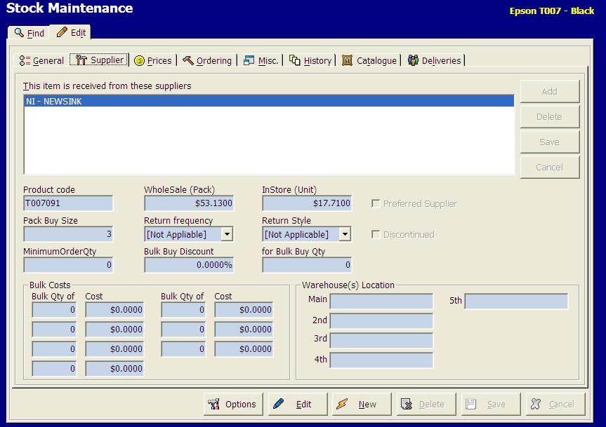

On the supplier screen you should ensure that your correct supplier is listed, that their supplier code, wholesale price, pack buy size, minimum reorder quantity are correct and most importantly that the supplier you always wish to order from has been marked as the preferred supplier.
The ordering program will always order in multiples of the pack buy size unless the option Creditor Breaks Packs on the purchasing tab of Creditor maintenance has been set for the creditor you are making the order for.

Next you should select the Ordering tab where you will be presented with a screen like the following.

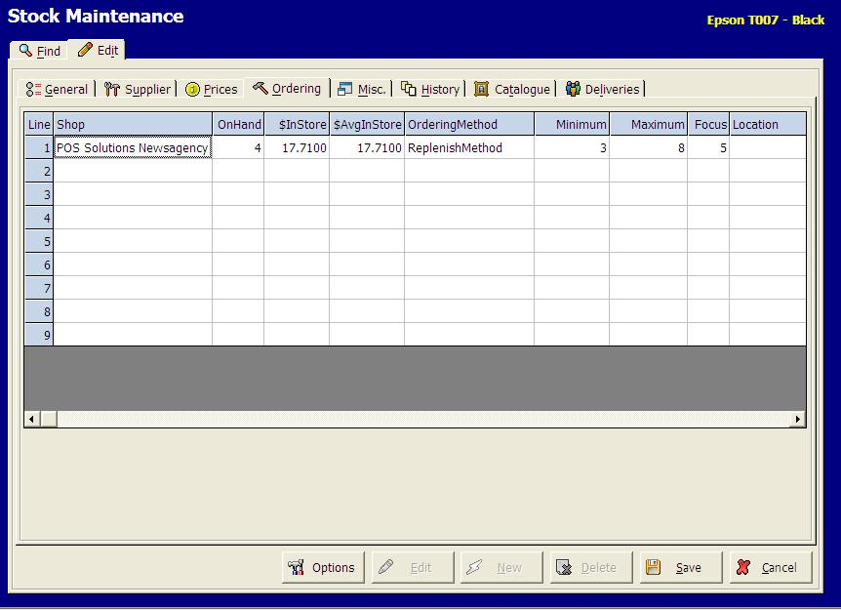

For each shop you should carefully set the entries on this screen to the values you require.
Onhand: The onhand figure is the current stock holding of this product. You should adjust this to the actual quantity of items on the shelf if you do not plan to do an initial stock take before using the automatic ordering facilities.
Ordering method: The ordering method in stock maintenance should be set to your preferred ordering method for this item. When creating an order you can choose to either use this value, override this setting or ignore all items that are not the same as this value.
For example if I set this option to replenish, when ordering I can either choose to order the item via replenish (as set in the stock item), override this setting and order it via MinMax or ignore it because I only want to order items set to MinMax.
An item can also be set to never be automatically ordered. This option can never be over ridded. That is if an item is set to NoAutomaticReordering, it will never be automatically ordered regardless of any setting in the ordering program.
Minimum: This is the minimum stock holding allowed before an item is to be re-ordered using the MinMax method. Note that the minimum value is specified in Pack Buy units and not individual items.
Maximum: This is the maximum stock holding that the MinMax ordering method will reorder up to. Note that the maximum value is specified in Pack Buy units and not in individual items.
Focus: This is the focus value as calculated by the focus engine. This value is automatically filled in and is not usually needed to be changed by the user. See appendix A for more details on the Focus engine.

Maintaining ordering details while receiving stock

Instead of calling up each item individually many users may find it much more convenient to maintain their ordering details while receiving stock.
On the entry grid in stock received press F2 to edit the item and then select the ordering tab as shown below.

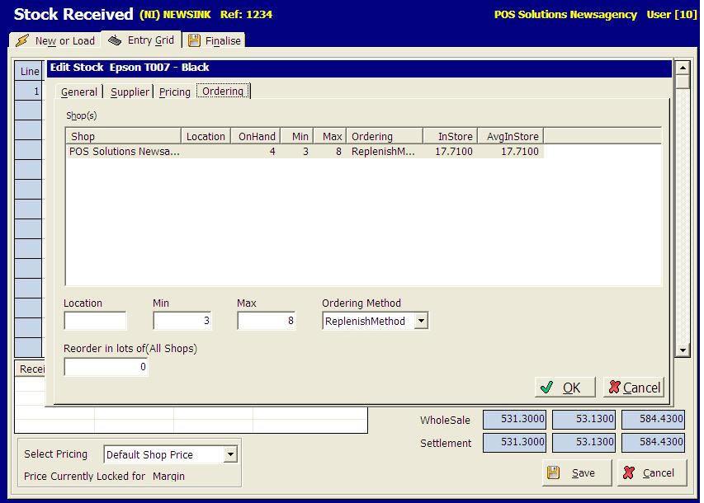

From this screen you should set the
Min: This is the minimum stock holding allowed before an item is to be re-ordered using the MinMax method. Note that the minimum value is specified in Pack Buy units and not individual items.
Max: This is the maximum stock holding that the MinMax ordering method will reorder up to. Note that the maximum value is specified in Pack Buy units and not in individual items.
Ordering method: The ordering method in stock maintenance should be set to your preferred ordering method for this item. When creating an order you can choose to either use this value, override this setting or ignore all items that are not the same as this value.
For example if I set this option to replenish, when ordering I can either choose to order the item via replenish (as set in the stock item), override this setting and order it via MinMax or ignore it because I only want to order items set to MinMax.
An item can also be set to never be automatically ordered. This option can never be over ridded. That is if an item is set to NoAutomaticReordering, it will never be automatically ordered regardless of any setting in the ordering program.
Reorder in Lots of: When set this determines the multiple of the pack buy size that must be ordered. For example if this is set to 2 and the pack buy size is 3 then stock will be ordered in multiples of 6 individual items.

Setting the ordering method in bulk

The order method for a group of items can be set in bulk via Stock Editing. On the search stock screen select Stock Detail, Active only and For stock editing. Then select your criteria and click Find. The following example will select all items via supplier:

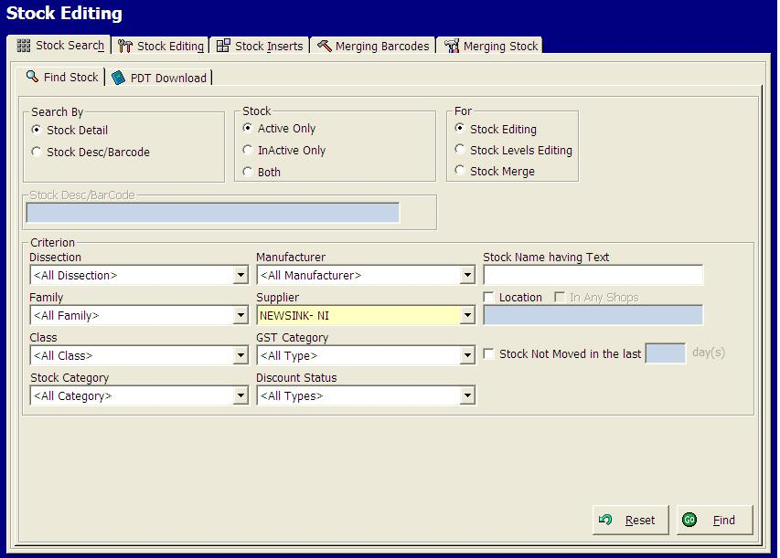

Next select the Stock Editing tab.
Tick the box to the left of the label Ordering and select your desired ordering method from the drop down box as shown in the diagram below.
Tick the option All Stocks in the middle of the bottom of the screen and click update.
All the items listed in the grid at the top of this screen will now have their ordering method change to the one you selected.

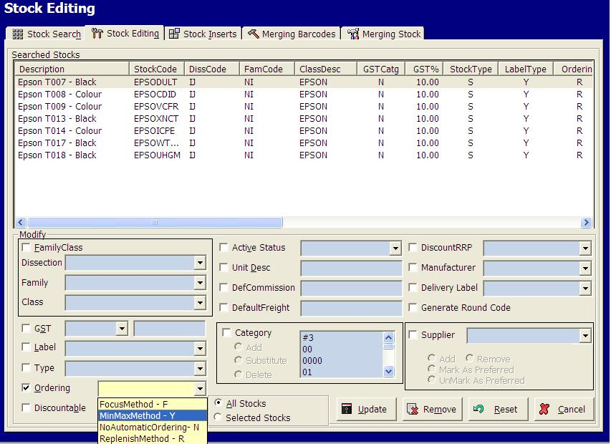

Creating an order:

To create an order you must first decide which method you wish to use. On the make order tab, start by selecting your ordering method. How the order and options available depend on which method you choose.

Make a blank form:
A blank form as its name suggests creates an order form without any entries. Your options here are

Order Shop: Select the scope of this order. That is whether the order is for a single shop or all shops. If appropriate select the shop you are ordering for.
Supplier/Manufacturer: Select whether you want to order for a single supplier, a single manufacturer or to order all items as needed. If ordering by a single supplier or manufacturer you will be asked to select the supplier or manufacturer. Any items on the order form will be limited to this supplier or manufacturer. Order all items as needed will create an order form to which you can add any stock items from any supplier or manufacturer.
Order Reference: Enter a reference number for this order or leave this option blank and a unique reference number will be generated for you.

Once these options have been set click “Generate Order” to make the order form.

PDT order:
Once you have scanned the orders you require into the PDT, select PDT order for the ordering method. Your options here are:

Order Shop: Select the scope of this order. That is whether the order is for a single shop or all shops. If appropriate select the shop you are ordering for.
Supplier/Manufacturer: Select whether you want to order for a single supplier, a single manufacturer or to order all items as needed. If ordering by a single supplier or manufacturer you will be asked to select the supplier or manufacturer. Any items on the order form will be limited to this supplier or manufacturer. Order all items as needed will create an order form to which you can add any stock items from any supplier or manufacturer.
Port: Enter the COM port that the PDT is connected to.
Order Reference: Enter a reference number for this order or leave this option blank and a unique reference number will be generated for you.

Click “Generate Order” and the order information will be downloaded from the PDT. You should ensure that the PDT is plugged in and ready to send data before pressing the “Generate Order” button.
You will now be ready to edit the order.

Replenish Method:
Replenish will restock your shelves based on the items that have been sold.

Order Shop: Select the scope of this order. That is whether the order is for a single shop or all shops. If appropriate select the shop you are ordering for.
Supplier/Manufacturer: Select whether you want to order for a single supplier, a single manufacturer or to order all items as needed. If ordering by a single supplier or manufacturer you will be asked to select the supplier or manufacturer. Any items on the order form will be limited to this supplier or manufacturer. Order all items as needed will create an order form to which you can add any stock items from any supplier or manufacturer.
For Replenish:
- Use sales for the last will create an order based on sales done in the last number of days that you enter.
- Period. Calculate the orders based on the sales in the period specified.
- Subtract on hand from Replenish Qty: If you reorder too many times using the replenish method you run the risk of being overstocked. This is especially the case when an item comes in a pack. For example if there has been one sale, but the item has a pack buy size of 3 then Posbrowser will order one pack of 3. If you then sell one more item and do another order Posbrowser will order another pack of 3 as this is the minimum order quantity. The problem here is that for the two items that have sold you are now ordering 6 new items. Subtract on hand from Replenish Qty takes the stock on hand into account so that when the second order is created a check is made to see how many items are in stock. In this case 3 items are on hand and we only need one, therefore the item will not be reordered leaving you with two items on the shelf and not 6. Using this option requires accurate stock on hand figures.
Only include Replenish items: will restrict the order to items that have their reordering method in stock maintenance set to Replenish. If this option is not set then all items will be reordered using the replenish method regardless of the setting in stock maintenance. The exception here is that items set to NoAutomaticOrdering in stock maintenance will not be ordered.
Restrictions: Restrictions allow you to restrict the items that are to be ordered using this method by category, dissection, family and class or location.
Round order quantities to: allows you to round the ordered quantities in different ways that may make your stock easier to handle or qualify you for supplier discounts.
Order out of stock items only: Only out of stock items will be ordered.
Order Reference: Enter a reference number for this order or leave this option blank and a unique reference number will be generated for you.

Once your options have been set then click Generate order and a replenish order will be created which you can then edit and process.

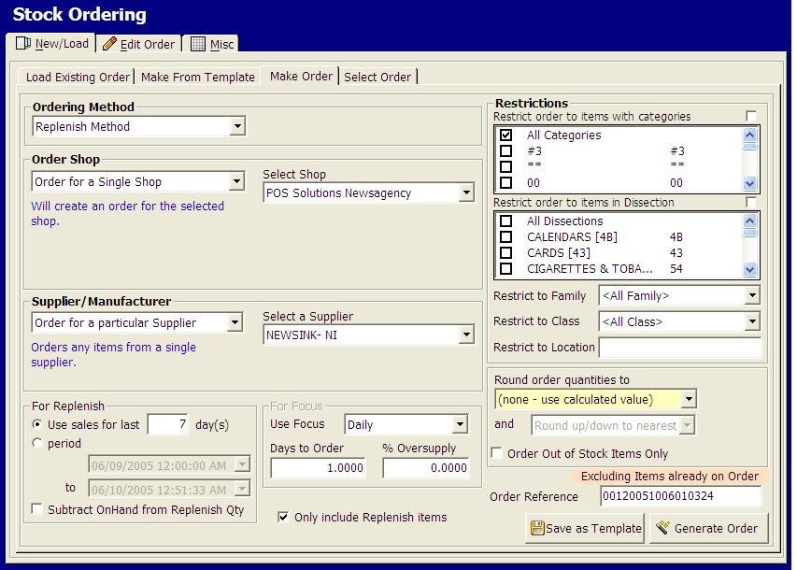

MinMax Method
MinMax will create an order based on the minimum and maximum stock holdings set for each stock item. Once the minimum level is reached items are ordered back to the maximum level. See the section Setting up your stock items for details on how to set the minimum and maximum stock levels.

You create a MinMax order by selecting MinMax Method from the Ordering Method drop down box where you will be presented with the following options:
Order Shop: Select the scope of this order. That is whether the order is for a single shop or all shops. If appropriate select the shop you are ordering for.
Supplier/Manufacturer: Select whether you want to order for a single supplier, a single manufacturer or to order all items as needed. If ordering by a single supplier or manufacturer you will be asked to select the supplier or manufacturer. Any items on the order form will be limited to this supplier or manufacturer. Order all items as needed will create an order form to which you can add any stock items from any supplier or manufacturer.
MinMax Order if Cheapest: If this option is chosen then the item will be ordered from the supplier with the lowest wholesale price in stock maintenance. There is no check to see when the item was last received so if you wish to use this option you need to make sure that your wholesale prices are up to date. If you do not select this option then either the supplier that is selected for the order form is used or if ordering for multiple suppliers then the preferred supplier in stock maintenance is used.
Only include MinMax items: Will restrict the order to items that have their reordering method in stock maintenance set to MinMax. If this option is not set then all items will be reordered using the MinMax method regardless of the setting in stock maintenance. The exception here is that items set to NoAutomaticOrdering in stock maintenance will not be ordered.
Restrictions: Restrictions allow you to restrict the items that are to be ordered using this method by category, dissection, family and class or location.
Round order quantities to: Allows you to round the ordered quantities in different ways that may make your stock easier to handle or qualify you for supplier discounts.
Order out of stock items only: Only out of stock items will be ordered.
Order Reference: Enter a reference number for this order or leave this option blank and a unique reference number will be generated for you.

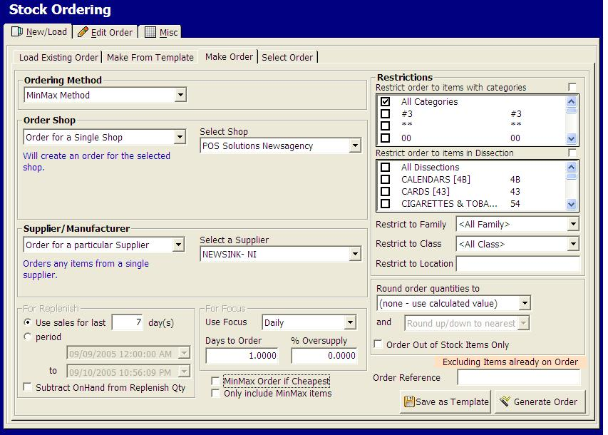

Focus Method

Focus will estimate future sales based on past sales history and enough items to cover the estimated future sales. To use the focus method you must generate focus data via the Misc tab or automatically via a scheduled program. See Appendix A for more details on the focus engine.

To create a focus order select Focus method from the ordering method drop down box where you will be presented with the following options:

Order Shop: Select the scope of this order. That is whether it is for a single shop or all shops. If appropriate select the shop you are ordering for.
Supplier/Manufacturer: Select whether you want to order for a single supplier, a single manufacturer or to order all items as needed. If ordering by a single supplier or manufacturer you will be asked to select the supplier or manufacturer. Any items on the order form will be limited to this supplier or manufacturer. Order all items as needed will create an order form to which you can add any stock items from any supplier or manufacturer.
For Focus:
- Use Focus: The focus engine calculates sales internally daily, weekly and monthly units. Which of these you choose will depend on the sales of the item. Fast or high volume selling items will work best if you choose daily but for slower moving items you will need to use weekly or monthly. You should start by creating daily, weekly and then monthly orders until you have worked out which setting works best for each suppliers stock lines.
- Days to order: Determines the number of days into the future that you wish to order for.
- % Oversupply: Adds this percentage to the order to make sure that there will always be enough stock and that you do not run out. This is to guard against the focus engine underestimating your sales. Use this option with caution as you could also end up being overstocked with items.
Only include Focus items: will restrict the order to items that have their reordering method in stock maintenance set to Focus. If this option is not set then all items will be reordered using the Focus method regardless of the setting in stock maintenance. The exception here is that items set to NoAutomaticOrdering in stock maintenance will not be ordered.
Restrictions: Restrictions allow you to restrict the items that are to be ordered using this method by category, dissection, family and class or location.
Round order quantities to: Allows you to round the ordered quantities in different ways that may make your stock easier to handle or qualify you for supplier discounts.
Order out of stock items only: Only out of stock items will be ordered.
Order Reference: Enter a reference number for this order or leave this option blank and a unique reference number will be generated for you.

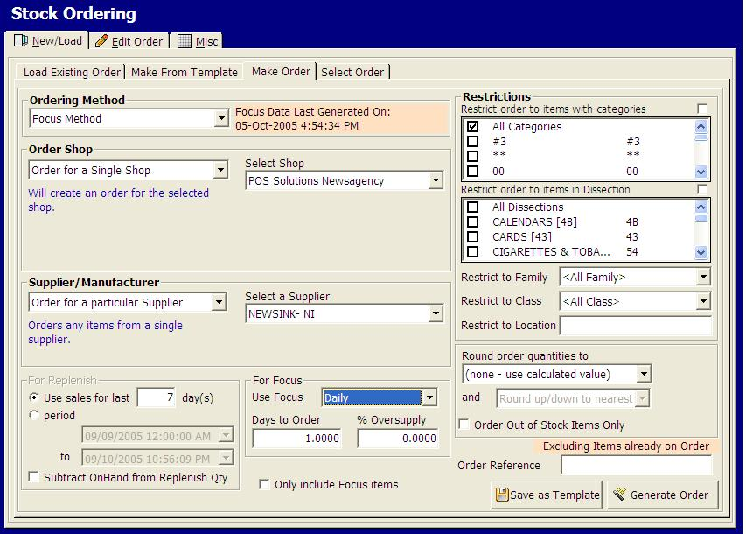

Method associated with the item

Method associated with the item creates an order based on the order method set for the individual stock item. All the options described in Replenish, Focus and MinMax are available and apply to the relevant stock items.

Select this option if you have different ordering methods associated with different products from the same supplier, family, class or category that you wish to combine onto the one order form.

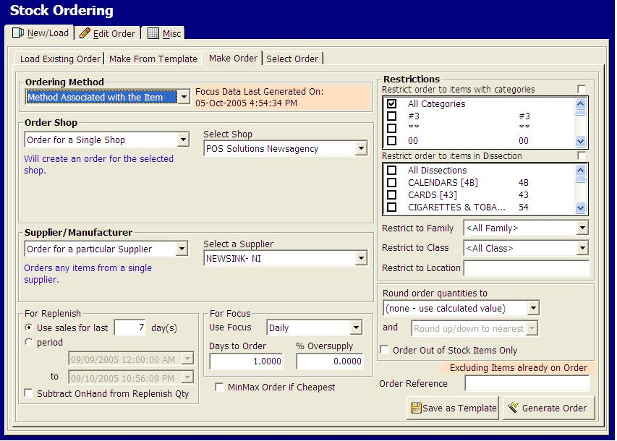

Appendix A – Focus Engine

Ordering via the focus method requires analysis of your previous sales history in order to estimate future sales. In order to speed up the ordering process Posbrowser calculates the sales in daily, weekly and monthly increments and stores the results against the stock item. If the focus data is not kept up to date then the figures used to estimate future sales will be inaccurate and the correct order will not be generated.

Focus data can be generated in Posbrowser in two ways:

Manually:
You can create the focus data at any time by going to
- Stock Ordering
- Misc Tab

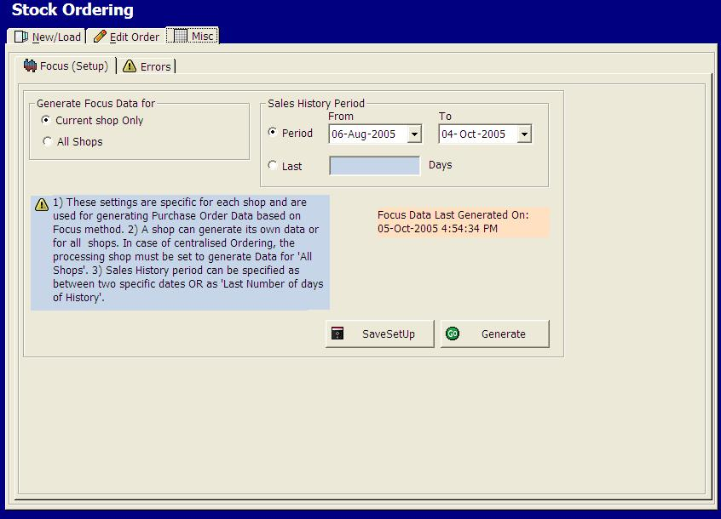

You will be presented with the following options:
Generate Focus Data for:
- Current Shop only: Only generate focus data for the current shop
- All Shops: Generate focus data for all shops
Sales History Period:
- Period: set the From and To dates you wish to use sales history for.
- Last: This will use the sales history for the previous number of days entered.
Save Setup: Saves the options you selected above.
Generate: Manually generated the focus data. Depending on the options selected above this process may be lengthy and may slow your server if done during busy trading hours.

Automatically via nightly process:
As manually generating the focus data during trading hours may slow down your server it is advisable to set up an automated process to generate the focus data during non-trading hours. The automated process is run via the Posbrowser Taskscheduler, which is the same scheduling program used to run the XchangeIT sales data collection program.

If you are already collecting sales data for XChangeIT then go to that computer and use the task scheduler available on it and proceed to the section Setting up the Focus Task. Otherwise select a computer that you will leave on all the time and perform the following steps. Remember that this is the computer that runs your scheduled tasks for future reference if asked by Pos Solutions Staff.

Installing the task scheduler program

- Close all programs so you can easily see the windows desktop
- Right click the Start button and click Open All Users
- Double click Programs and then Startup
- Double click My Computer and navigate to C:\Program Files\Posbrowser
- Right click the program Taskschedule.exe in the Posbrowser directory and drag it to the Startup folder. Release the right mouse button and select Create Shortcut here. Do not copy the program as the task scheduler will be unable to be updated in the future if need be.
- Right click the item Shortcut to Taskschedule.exe and select rename with the left mouse button and rename it to Taskschedule.exe
- Restart the computer in the normal method to load the Task scheduler program

Setting up the Focus task
- Double click the task scheduler, which is the brown clock icon with hands at 10 to 2 near the time in the bottom left of the screen.
- Click the Modify tasks tab
- Click New Task
- In the description box type Focus engine
- In the path box type Focus.exe
- Tick the option marked Use default path
- Set the launch time to 5:00AM or another suitable time outside trading hours.
- Set the Launch Frequency to Once Daily
- Click save

You should be aware that the focus program will not run if it is scheduled between 8am and 9pm. The focus program cannot be set to run between 1am and 2am as this time is set aside for routine database maintenance jobs and access to the database may be briefly interrupted during this period.
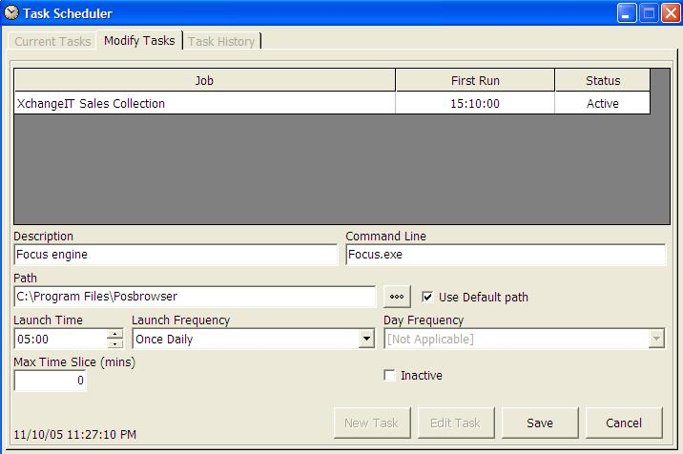

Appendix B – Excluding items already on an order
Posbrowser considers items to be on order when the item is included on either a saved order form in the Stock Ordering section or a converted purchase order in Stock Received that has not yet been processed.

By default if an item is already on order when a new order form is automatically generated, the quantity that is already on order will be deducted from the order quantity to prevent over ordering.

For example if the ordering program feels that 6 items are to be ordered but 4 are still on order and have not been received it will only order 2 items.

We recommend that you keep this setting to prevent you becoming overstocked by creating orders containing the same items, however if you are testing and comparing different ordering methods, and we strongly suggest you use the training system for this, you will want to order the same items a second time.

To allow Posbrowser to order items that are already on order:
- System Maintenance
- System setup values
- Select Other options
- Change the entry While ordering, check items already on order to No.
There will be a change on the create order page to signify the setting of this option:
Not excluding items already on order will show in the bottom right hand corner instead of Excluding items already on order.
To change this setting back to the default simply change the option back to Yes. Before the change will take effect you will need to unload the ordering document and reload it.

