Welcome to POS Solutions

We care about your safety, so we taking all measures to ensure your safety.

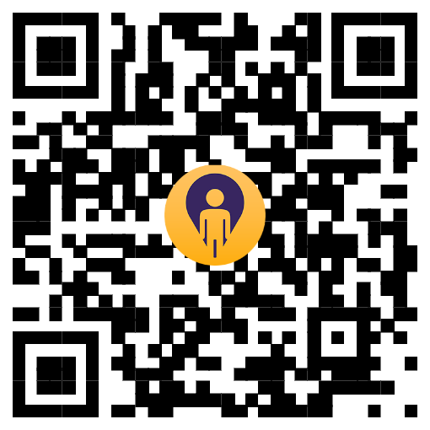

-Scan this QR code on your smartphone and click the link

-Then please enter your first name and your mobile number.

-You can also enter your email address as an additional contact point if you would like.

WHY ARE WE DOING THIS?

We are required to be able to provide the health authorities details for people in our shop at a date and time of interest should they be tracing those who may have had contact with someone diagnosed with COVID.

YOUR PRIVACY is important to us.

-The information is not held by us.

-We will not share your details unless demanded by government health authorities.

-The information will be deleted automatically in accordance with government requirements.

Thank you for helping us all stay safe.

