How to change the Sydney Morning Herald paper price for the upcoming increase

The Sydney Morning Herald is having a price increase from Saturday February 27, 2010. The new weekday price (Mon-Fri) will be $1.50 and the Saturday price will be $2.50 (both 10c increase).

Changing the Paper price can be completed at any point in time between now and February 27, 2010 as long as the steps below is followed.

From the Main Menu go to #3 Updating System section.

1) Go to #2 Paper Maintenance.

2) Call up the Sydney Morning Herald paper.

3) Change the price of the weekday papers to $1.50 and the Saturday edition to $2.50 as seen below.

Move the old price structure of the Sydney Morning Herald to the "top" fields.

Put in the From Date 27/02/2010 and place the prices on the bottom where shown 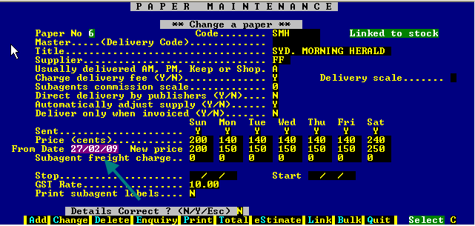

4) Page down and save the details.

