SETTING UP POS SOLUTIONS TO TRANSFER TO MYOB

Pos Solutions is no way resposible for the day to day operations of MYOB and any problems that may occur with using this package. Pos Solutions is not and have never claimed to be accountants, and this inforamtion is not intended to replace proffesional advise related to the myob package.

SECTION #1

WHAT THE POS PROGRAM EXPORTS TO MYOB.
DEPARTMENT SALES AMOUNTS, TRANSFER OF DAILY TAKINGS, INVOICED AMOUNTS, CREDIT AMOUNTS, RETURN AMOUNTS, STOCK INVOICE FEES.

- FIRSTLY INSTALL MYOB AND CREATE THE DATABASE FOR A NEWSAGENCY, MYOB HAS THE FACILITY TO BE ABLE TO SET UP A STANDARD DATABASE FOR NEWSAGENTS. AND IF YOU DO THIS THE DATA EXPORT FROM POS WILL TRANSFER INFORMATION DIRECTLY INTO MYOB WITH VERY LITTLE ADJUSTMENT.

IF YOU DO ALTER ANY OF THE FOLLOWING
:ASSETS
:LIABILATY
:EQUITY
IN MYOB YOU WILL THEN NEED TO GO THRU AND ALTER ANY OF THE RELEVANT DETAILS FOR THE POS SYTEM.(explained later)

- IF YOU ARE CURRENTLY USING A VERSION OF MYOB THEN YOU WILL NEED TO PRINT OUT A CHART OF ACCOUNT SUMMARY. ONCE YOU HAVE THIS IT IS JUST A MATER OF TRANSPOSSING OVER THE ACCOUNT NUMBER INFORMATION IN TO THE RELEVANT SECTIONS IN POS. (explained later)

SECTION #2

THE ACCOUNT PACKAGE TRANSFER LOCATION.

- FROM THE MAIN MENU CHOOSE THE OPTION NUMBER #11 CASHBOOK

- WHEN IN THE CASHBOOK MENU CHOOSE OPTION #6 ACCOUNTS PACKAGE TRANSFER.

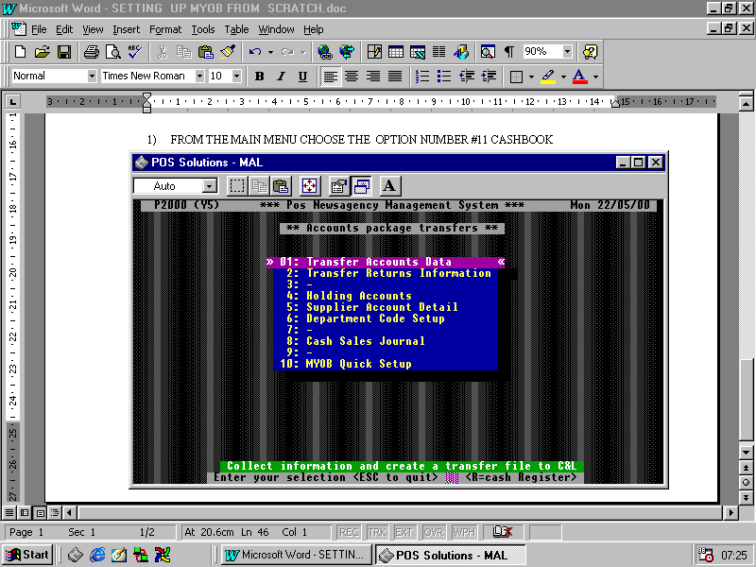
- THIS WILL TAKE YOU TO THE FOLLOWING SCREEN

- FROM THIS SCREEN YOU SHOULD NOW GO TO #10 AND RUN THE MYOB QUICK SETUP.

SECTION #3

SETTING UP POS OPTIONS FOR THE MYOB TRANSFER FILE CREATION.

- FROM THE MAIN MENU GO TO UPDATING SYSTEM SECTION #3

- THEN #9 OPTIONS

- THEN TO #18 CASHBOOK IN HERE YOU WILL SEE THE FOLLOWING SCREEN.
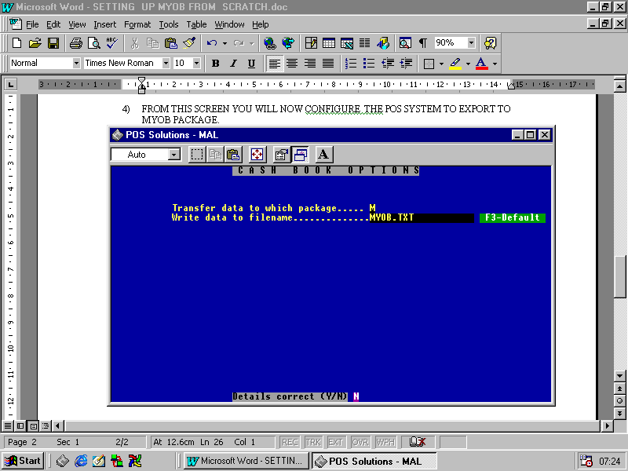

4) IF YOU ARE RUNNING A DOS NETWORK

YOU WILL NEED TO CHANGE THE BOTTOM OPTION TO READ

WRITE DATA TO FILENAME …………………………A:\MYOB.TXT
THIS WILL SET THE DESTINATION OF THE GENERATED POS EXPORT FILE.

5) IF YOU ARE RUNNING A WINDOWS NETWORK

THE FIRST THING YOU SHOULD DO IS GO TO QUIT OUT OF THE SYSTEM BACK TO THE ABC MENU THEN PRESS F10, THIS WILL TAKE YOU TO A BLACK SCREEN WITH A DOS PROMPT ON THE LEFT HAND SIDE.

YOU WILL NEED TO WRITE DOWN WHAT THE NETWORK DRIVE LETTER IS IE: G:\ OR E:\ ect, THIS IS WHERE THE POS EXPORT FILE WILL BE PLACED.
TO GET BACK INTO THE ABC MENU YOU SHOULD PRESS M AND ENTER.

YOU WILL NEED TO CHANGE THE BOTTOM OPTION TO READ

WRITE DATA TO FILENAME …………………………G:\MYOB.TXT
( THAT IS IF THE NETWORK DRIVE IS G: IF IT IS ANOTHER DRIVE REPLACE IT WITH THE CORRECT LETTER ).
THIS WILL SET THE DESTINATION OF THE GENERATED POS EXPORT FILE.

YOU WILL ALSO NEED TO CHANGE THE OPTION IN NUMBER #13 CASH REGISTER FROM THE OPTIONS MENU IT READS AS FOLLOWS.

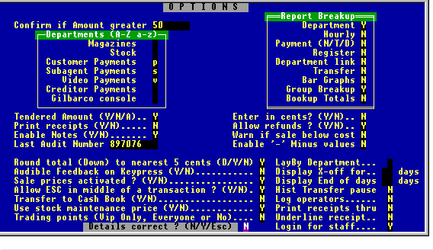
Located Here

TRANSFER TO CASHBOOK (Y/N) THIS MUST BE CHANGED TO Y
THIS OPTION IS LOCATED ON THE LEFT HAND SIDE THIRD FROM THE BOTTOM.

NOW WHEN YOU DO A EOD THE DAILY TRANSFER INFORMATION WILL BE COLLATED AND STORED ON THE FLOPPY DISK, OR THE NETWORK DRIVE THAT YOU HAVE SPECIFIED.

SECTION #4

USE THIS SECTION FOR USERS WHO HAVE NEVER USED AND HAVE CREATED A NEW STANDARD NEWSAGENCY DATABASE IN MYOB

IF YOU HAVE NEVER USED MYOB AND HAVE JUST CREATED A NEW DATABASE, AS OUTLINED IN SECTION #1 STEP 1) THEN ALL YOU WILL NEED TO DO IS MAKE SURE YOU HAVE FOLLOWED THE INSTRUCTIONS OUTLINED IN SECTION #2 NUMBER 4).

ONCE THIS HAS BEEN DONE THEN THE POS SYSTEM IS NOW READY TO EXPORT INFORMATION DIRECTLY TO A MYOB STANDARD NEWSAGENCY DATABASE.

IF YOU ARE RUNNING A DOS NETWORK THEN YOUR MYOB EXPORT FILE WILL BE LOCATED IN THE (A:) DRIVE AND GENERATED WITH THE END OF DAY.

IF YOU ARE RUNNING A WINDOWS NETWORK THE FILE WILL BE LOCATED IN THE NETWORK DIRECTORY YOU SPECIFIED IN SECTION #3 NUMBER 5) AND GENERATED WITH THE END OF DAY.

SECTION #5

USE THIS SECTION IF YOU ARE ALLREADY USING THE MYOB PACKAGE AND HAVE A DATABASE SETUP THAT YOU ARE CURRENTLY USING.
OR IF YOU ARE ALTERING THE MYOB DATABASE FROM THE ORIGINAL NEWSAGENCY DATABASE SETTINGS.

THE FIRST THING YOU SHOULD BE LOOKING TO DO IS PRINT A CHART OF ACCOUNT (SUMMARY) OUT OF MYOB. ONCE YOU HAVE THIS GO TO.

- MAIN MENU
- #11 CASHBOOK
- #6 ACCOUNT PACKAGE TRANSFER

THE MAIN OBJECTIVE IS TO TRANSFER OVER THE ACCOUNT NUMBERS FROM MYOB INTO POS SYSTEM.

THE BEST PLACE TO MAKE A START.

- HOLDING ACCOUNTS.
THE NUMBERS THAT ARE LOCATED IN HERE FOR THE TAKINGS, ARE DERIVED FROM THE ASSETS ACCOUNT LIST IN MYOB.
THESE NUMBERS RANGE FROM 1-1000 ONWARDS AND AS A DEFAULT ARE LOCATED UNDER THE CASH ON HAND IN MYOB. IF YOU HAVE BROKEN MYOB UP IN SUCH A WAY AS TO USE DIFFERENT ACCOUNT NUMBERS FOR THE CASH ON HAND THEN YOU WILL NEED TO TRANSPOSE THE MYOB ACCOUNT NUMBERS ACCORDINGLY TO THE CORRECT LOCATION IN POS.
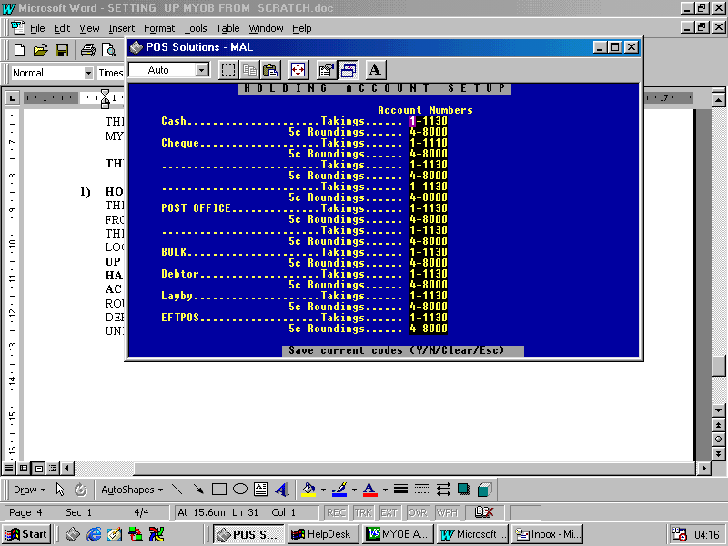
AS FOR THE ROUNDINGS, YOU WILL BE ABLE TO SEE THAT ALL ROUNDING IS LOCATED TO A DEFAULT OF 4-8000, THIS DEFAULTS TO A MISCELLANIOUS INCOME IN MYOB UNDER THE ACCOUNTS LIST FOR INCOME.

AND IF YOU HAVE SET ANY ROUNDING ACCOUNT NUMBER THAT ARE DIFFENT IN MYOB THEN IT WILL NEED TO BE TRANSPOSED IN TO POS SYSTEM.

- SUPPLIER ACCOUNT DETAILS.
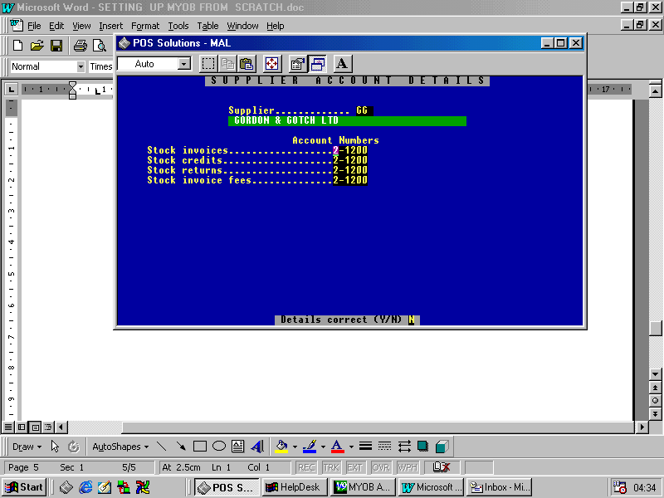
THE NUMBERS THAT ARE LOCATED IN HERE ARE FOR THE SUPPLIERS, THEY ARE DERIVED FROM THE LIABILITY ACCOUNT LIST IN MYOB.
AS A DEFAULT THEY ALL GO TO TRADE CREDITORS, IN THE ACCOUNT RANGE OF 2-1200. IF YOU HAVE ALTERED YOUR MYOB WITH DIFRFENT ACCOUNT NUMBERS FOR DIFFERENT SUPPLIERS THEN YOU WILL NEED TO TRANSPOSE THE

INFORMATION ACCORDINGLY INTO EACH SUPPLIER THAT YOU HAVE SET.
THE POS SYSTEM WILL TRANSFER TO MYOB THE INVOICE AMOUNT, CREDIT AMOUNT, RETURNS AMOUNT FOR THE PARTICULAR DAY AND THE INVOICE FEES FOR EACH CREDITOR ON A DAILY BASIS.

- DEPARTMENT ACCOUNT SETUP.
THE NUMBERS THAT ARE LOCATED IN HERE ARE FOR THE DAILY SALES FOR EACH DEPARTMENT. IF IN MYOB YOU HAVE A BREAK UP OF THE DEPARTMENTS LOCATED IN THE INCOME ACCOUNTS LIST. THEN YOU WILL ALSO NEED TO TRANSPOSE OVER IN TO EACH DEPARTMENT THE CORRECT ACCOUNT NUMBER RANGING FROM 4-1000 ONWARDS.
THERE IS ALSO THE NEED TO SET THE STOCK INVOICES, STOCK CREDITS, STOCK RETURNS, ACCOUNT NUMBER ACCORDINGLY IF YOU HAVE MODIFED IT AS WELL.

IF YOU HAVE NOT ALTERED THE ACCOUNT NUMBERS THEN THE THEY ARE DEFAULTED TO THE STANDARD MYOB ACCOUNT NUMBERS IE:
BOOKS 1-1310
MAGS 1-1320

STATIONARY 1-1330
THESE NUMBERS ARE LOCATED IN THE ASSETS ACCOUNTS LISTOF MYOB.
IF YOU HAVE ALTERED THESE THEN THE INFORMATION WILL NEED TO BE TRANSFERRED ACCROSS TO POS SYSTEM.
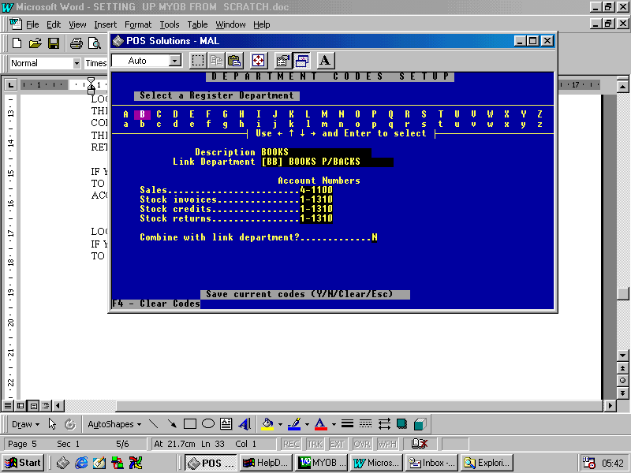
ONCE ALL THE ACCOUNT DETAILS HAVE BEEN TRANSFERRED TO THE CORRECT DEPARTMENTS AND YOU ARE SURE THAT EVERYTHING HAS BEEN SET CORRECTLY YOU ARE READY TO PROCEED TO THE NEXT STEP.

SECTION #6

HOW THE EXPORT FILE IS GENERATED.

- FROM NOW ON EVERYTIME YOU DO A EOD THERE WILL BE A FILE GENERATED AND PLACED INTO THE LOACTION YOU SPECIFIED IN SECTION # 3 NUMBER 4)OR 5). THE FILE ITSELF WILL BE CALLED MYOB.TXT.

- AS OUTLINED IN SECTION # 3 IF YOU ARE RUNNING A DOS NETWORK, THEN WHEN YOU DO A END OF DAY YOU WILL NEED TO PLACE A FLOPPY 3.5 INCH DISK IN THE DRIVE A: OF THE MACHINE THAT YOU ARE DOING THE END OF DAY ON. THE POS SYSTEM WILL GENERATE THE MYOB.TXT FILE AND PLACE IT IN THE A: DRIVE.

- AS OUTLINED IN SECTION # 3 IF YOU ARE RUNNING A WINDOWS NETWORK, THEN WHEN YOU DO A END OF DAY THE MYOB.TXT FILE IS GENERATED AND WILL BE PLACED ON THE IN THE LOCATION YOU HAVE SPECIFIED.

- THERE WILL BE A NEW SCREEN THAT WILL APPEAR WHEN DOING A END OF DAY THE SCREEN WILL APPEAR AS OUTLINED BELOW.
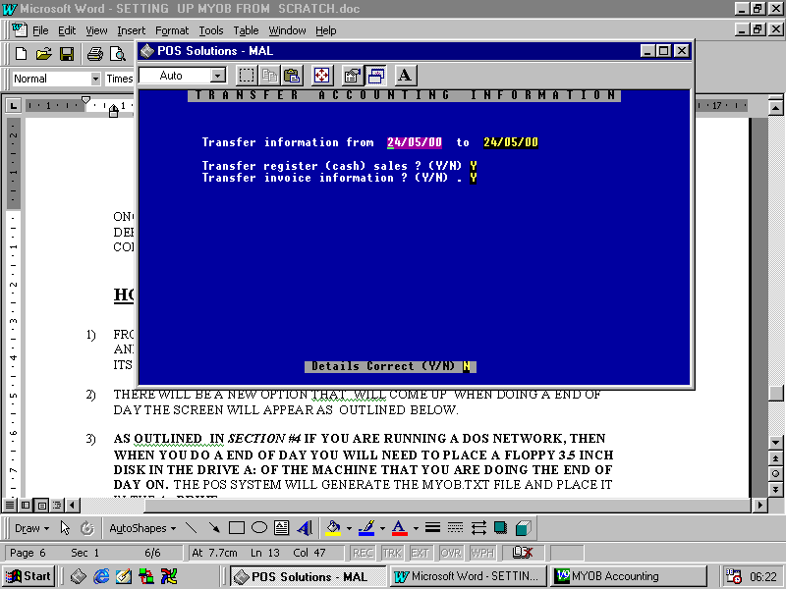

THE DEFAULTS ON THIS SCREEN ARE STANDARD AND YOU CAN PAGE DOWN AND SELECT YES. UNLESS YOU ARE ONLY TRANSFERING EITHER REGISTER SALES OR THE INVOICE INFORMATION, IF SO YOU WILL NEED TO CHANGE THE OPTIONS OUTLINED ABOVE.

SECTION #7

IMPORTING THE GENERATED MYOB.TXT FILE THAT POS SYSTEM HAS CREATED.

BEFORE IMPORTING THE POS MYOB.TXT FILE IN TO THE MYOB PROGRAM IT MAY BE A WISE DECISION TO FIRSTLY BACK UP YOUR CURRENT MYOB DATABASE FILE, OR COPY AND RENAME IT TO SOMETHING ELSE SO YOU CAN PLAY AROUND WITH A TRIAL DATA BASE. DUE TO THE FACT THAT MYOB SAVES THE INFORMATION THAT YOU IMPORT STRAIGHT AWAY, IF YOU HAVE VERSION 9 OR GREATER. MEANING THAT IF YOU ARE JUST STARTING AND MAY BE JUST TRYING THE IMPORT FOR THE FIRST TIME IT WILL SAVE THE INFORMATION AND ONCE IT HAS IMPORTED THE FIGURES IN TO MYOB IT CAN BE DIFFICULT TO GET THEM OUT.

- ONCE YOU HAVE OPENED MYOB UP CLICK ON FILE THEN IMPORT AND THEN SELECT GENERAL JOURNAL IMPPORT.

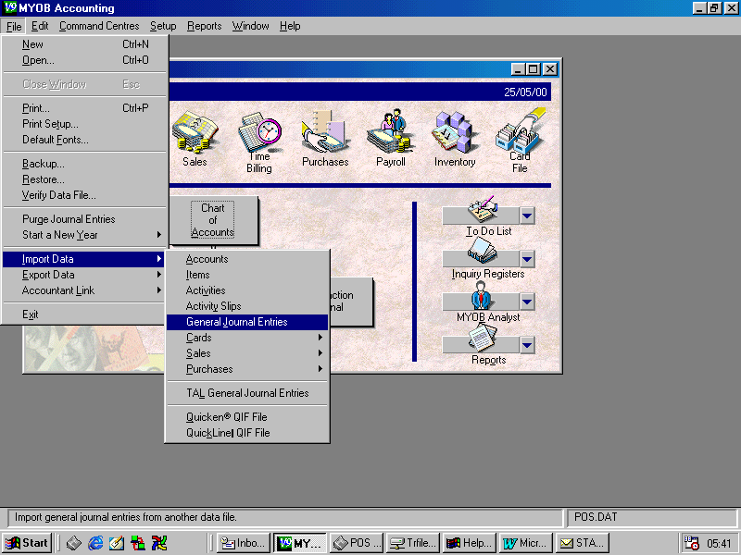

- THE NEXT SCREEN IS LABELED IMPORT FILE AND ALL YOU HAVE TO DO IS PRESS THE CONTINUE BUTTON.

- YOUR NEXT SCREEN IS IMPORTANT AS IT THE SCREEN THAT YOU WILL USE TO FIND THE MYOB.TXT FILE.
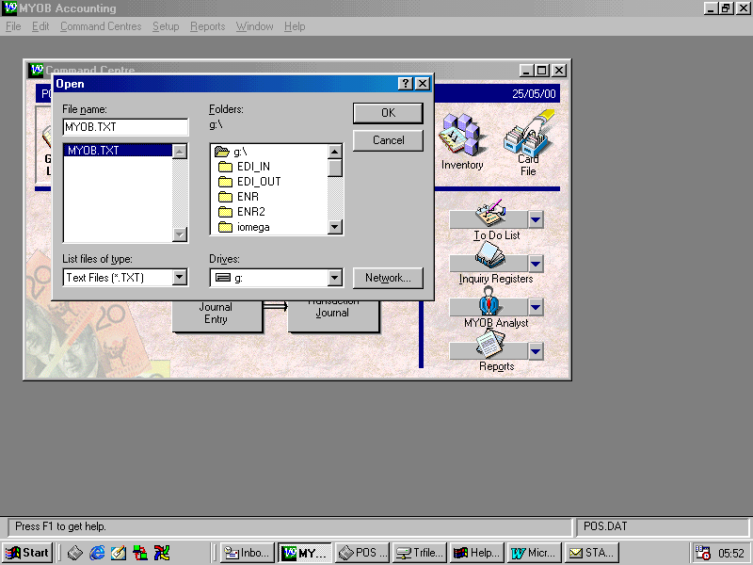
YOU ARE PROMPTED TO FIND THE LOCATION OF THE FILE YOU MAY NEED TO CHANGE THE DRIVE LOCATION TO THE CORRECT DRIVE LETTER WHERE YOUR FILE IS LOCATED. YOU WILL NEED TO CLICK ON THE MYOB.TXT FILE AND THEN CLICK THE OK BUTTON TO PROCEED TO THE NEXT SCREEN.
- THE NEXT SCREEN YOU WILL SEE IS THE IMPORT DATA SCREEN YOU SHOULD CLICK ON MATCH ALL AND THEN CLICK ON IMPORT.

- YOU WILL THEN SEE THE IMPORT JOURNAL ENTRIES SCREEN. IF YOUR TRANSFER HAS GONE ACCORDING TO PLAN YOU WILL HAVE A SCREEN SIMILAR TO THE FOLLOWING.
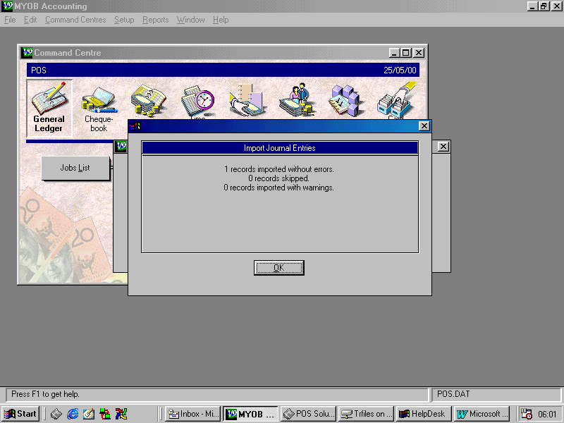
IF THERE HAS BEEN ANY PROBLEMS WITH THE MYOB IMPORT THE MESSAGE WILL DISPLAY 1 RECORD SKIPPED AND A LOCATION FOR THE EXPLANATION OF THE SKIPPED RECORD.

