POS ✓ SOLUTIONS AUSTRALIA PTY LTD
ACN 006 195 400

Please address all correspondence to: 23 Tuck Street,
P.O. Box 2194 Moorabbin, Victoria 3189.
Moorabbin VIC 3189 Phone: (03) 9597 72222, Fax: (03) 9532 2778

How to setup and use on the DOS system email statements.

Setup

Pick the computer that you will be doing the email statements on; it must have Outlook or Microsoft Express installed.

On that computer

If they are not already added on that computer add the POS Windows utilities
http://www.possolutions.com.au/information-sheets/category/5-file-downloads

These are designed to allow POS DOS to use window functions.

Windows options
Go to main menu
#3 Updating
#9 Options
#12 Windows

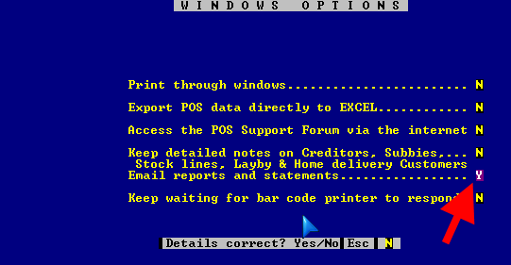

Email reports and statements……………….Y

Page Down and save.

Email details
Go to main menu
#3 Updating
#9 Options
#8 Email details
Please fill out all the boxes.

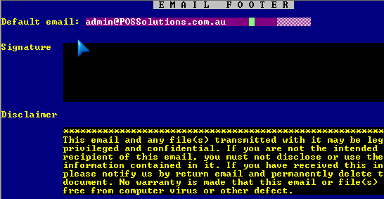

Page Down and save.

Exit POS Solutions
Now go out of the program back to the ABC and go back in

Test Run
Now for a test run add an email address to a customer by.

Go to main menu
#1 Customer
#1 Maintenance

Go C=Change

Call up a customer

F5-ID Numbers

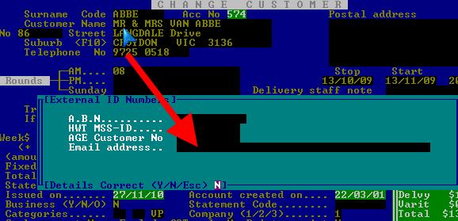

Add an email address
Page down and save.

Then page down and save again.

Print statements

There should be a new option on the bottom with Email, see red arrow.

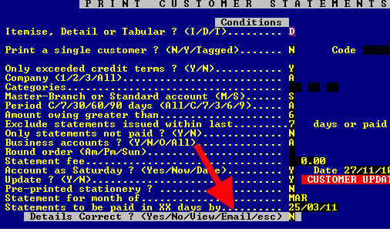

Go E=Email

It will create a report screen with the statement there for you to check.

If you are satisfied that it is right in the report screen go E=Email

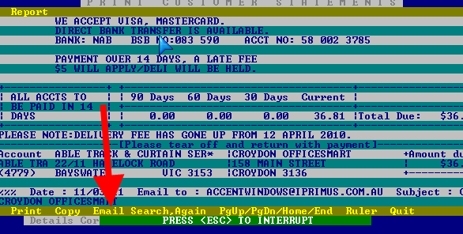
Now go Q=Quit
And update statements if correct.

Sending Emails

Go to main menu
#3 Updating system section
#28 POS Mail Processing

High the line that you wish to send and press enter.

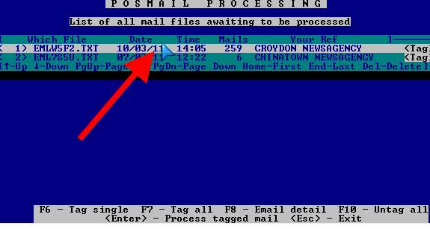

The email should be sent.

Command line options

This section is only to be used by a skilled operator, it is primary designed to turn off the email on a particular computer.

In the autoexec.bat file
SET ENR_WIN=
The fifth space Y=Email, N=No email, Blank = default

