POS ✓ SOLUTIONS AUSTRALIA PTY LTD
ABN 91 006 195 400

Please address all correspondence to: 23 Tuck Street,
P.O. Box 2194 Moorabbin, Victoria 3189.
Moorabbin VIC 3189 Phone: (03) 9532 2733, Fax: (03) 9532 2778

Instructions for the installation and configuration of XchangeIT and the Pos system for transmission of invoice & sales information between the newsagent and their magazine suppliers

By now, you will have either downloaded a version of XchangeIT from the website or received it on a CD that was mailed to you. If you haven’t registered your details and paid your fees to XchangeIT, using the internet, go to www.xchangeit.com.au and click on Membership Registration. Follow the prompts to fill in your business information and enter your payment details. Then select the method by which you wish to receive your copy of the XchangeIT software – download it or have it mailed. The files are very large and if you only have a standard modem connection to the internet, it may be far easier and less time consuming to request the CD version be mailed to you.

This document serves to help you with the installation of the XchangeIT software package and the subsequent set up of the Pos Solutions Newsagency Management System so that both packages interface as designed. Of course, by this stage, you will have a full windows network in place as this is a requirement of XchangeIT’s interface with the Pos system.

Stage 1: Installing the XchangeIT software on your computer system

To install XchangeIT, double-click on the file ‘NewsagentInstaller.exe’ located in the directory where you downloaded the software, or from your CD drive. If you downloaded the software from the website, to find the location where it was saved, double click the ‘My Computer’ icon on your windows desktop and then double click the ‘C’ drive icon that appears there. The folder where you downloaded the software from the website is most likely to be one of those that appears here. If you are going to install the software from the CD that was sent to you, double click the CD-Rom drive letter as appears in this screen.

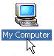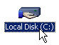

You will then be given the opportunity to select the directory in which to install the software. You are best to leave this as default (it will be usually be c:\programfiles\xchangeit). Select Yes or Next for all prompts that follow, as this will ensure a standard setup across the board and at the end of the installation process you will be prompted to click the Finish button. At the completion of this installation process, there will have been three new icons added to your windows desktop. One is for the XchangeIT interface, where all settings relating to XchangeIT’s operation & use are made, one is for the XchangeIT scheduler, which controls the automated dial up of XchangeIT for invoice collection and sales data transmission and one is for the automated update program, which is used to upgrade your version of the XchangeIT software.

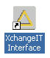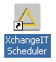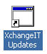

Stage 2: Placing the newsagent.dat file in the correct location

When you registered as a user on the XchangeIT web site, a data file was created with all of your details so that they could be verified when it comes to your application for partnerships with each of the magazine suppliers. This file, before you apply for any partnerships must be copied into the correct location on your machine’s hard disk. Unless you already have this file on disk, navigate yourself, using the internet, to the XchangeIT website and to the location where you logged in as a user. Once here, left click the software download option, followed by left clicking Option 2: Download software in segments. Under Step 2, is the option to Right click to download XchangeIT Details file (newsagent.dat). Right click this option and you will be prompted to either open it or copy it to disk. Select ‘copy to disk’ and a pop-up window will appear. Left click on Save Target As.

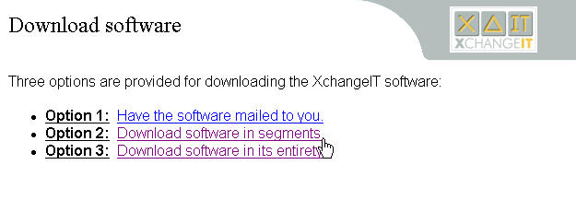

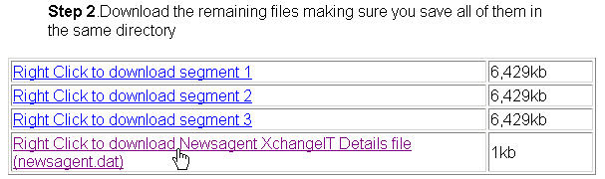
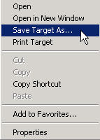

A box will appear asking you to select the location where the newsagent details file will be saved. This location needs to be in the config folder that exists under the XchangeIT folder that would have been created when you installed the software. On your main hard disk, which is usually called C drive, there will be a folder called Program Files. This folder will contain the XchangeIT and subsequent config folders for which you are looking. If C drive does not appear in the screen, left click the drop down arrow that appears at the right hand end of the rectangular Save in: box and select it from the list which appears. Then double click on the Program Files folder, after which you double click the XchangeIT folder. The config folder is found under this next listing. Double click it and then click Save. A file by the same name will already be in existence, so when asked whether you wish to overwrite the original copy, left click on Yes. The diagrams below illustrate how to go about saving the newsagent details file in the correct location on your computer.
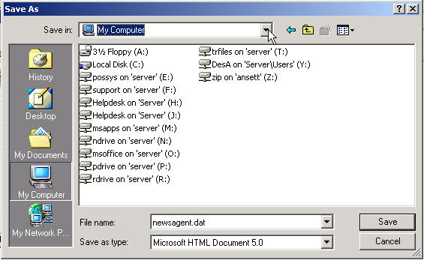
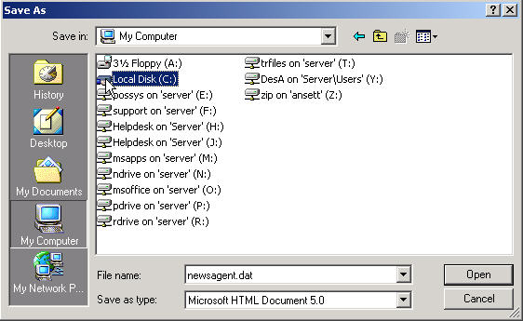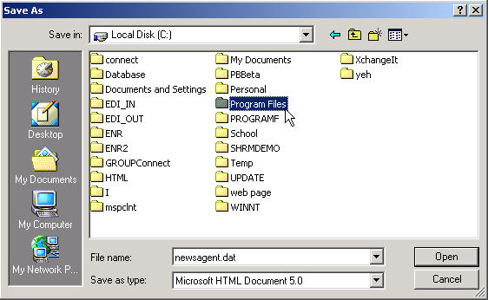

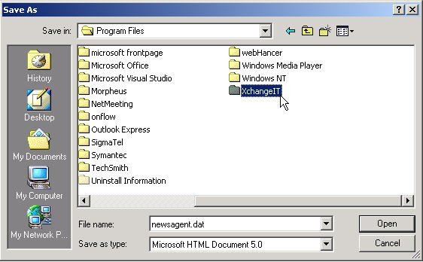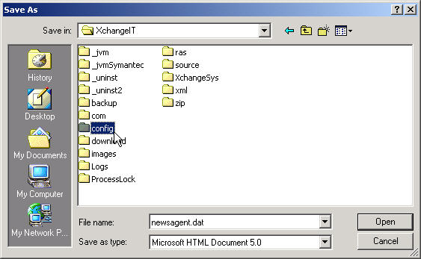

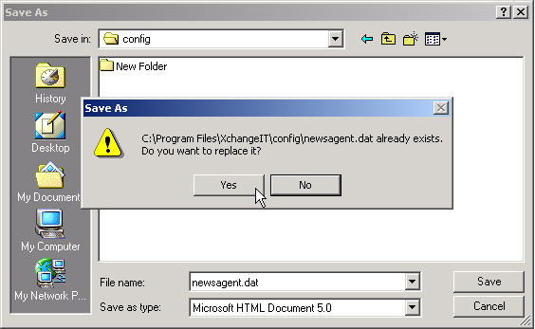

You can then disconnect from the internet.

Stage 3: Configuring the XchangeIT interface

Before you can apply for partnerships with the 2 magazine suppliers, you must configure the XchangeIT software so that the invoice files that come into the system (ddo files) and the sales files that are transferred out of the system back to the suppliers (sld files) are being stored in the correct locations. You will also need to set the times at which you wish XchangeIT to dial out for the transfer of these files, as well as the dial up service that XchangeIT is to use to connect to the internet. This stage will step you through these processes.

From the windows desktop, double click on the Newsagent Interface icon. This will open two windows. One of them is for the actual interface (the screen where you adjust the settings etc), the other is for the Java program which controls the running of the Interface. Both windows are required to be open by XchangeIT for it to function, as is the XchangeIT scheduler, if you wish XchangeIT to dial automatically. The XchangeIT interface will appear as below.

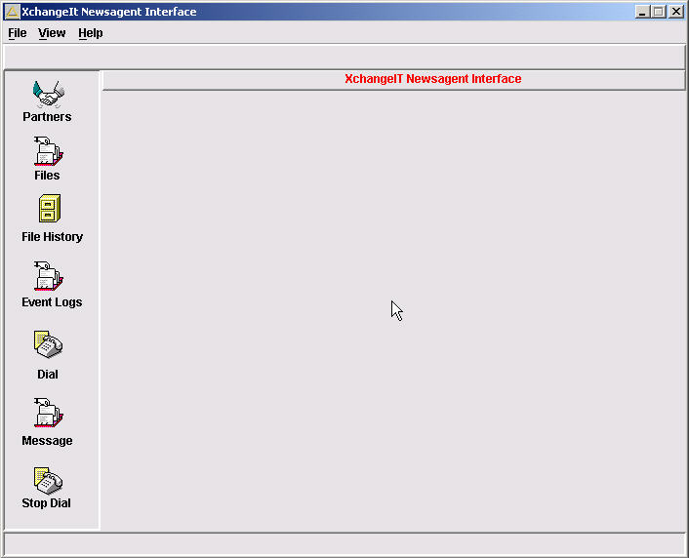
XchangeIT Interface Screen

Left click on View in the top menu of the interface screen, then on Configuration. This will display the configuration details of the interface. There will be a series of tabs listing areas requiring set up, of which only 3 concern you. These are Source Files, Timer & Dialup Networking.

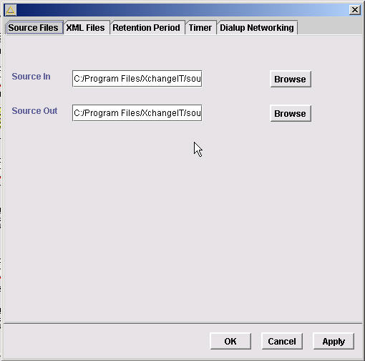
Configuration Details Screen

The Source Files tab will already be selected, displaying the locations of the in and out folders for the ddo and sld files respectively. The default locations as entered on installation need to be edited so that they are more easily accessed if any diagnostics need to be performed. Click in the rectangular box labeled Source In and delete it’s contents. We need to match this location with the hard disk on which the Pos system is accessed by this machine. The easiest way to find out this drive letter is to go out to Pos, and from the ABC menu, press the F10 key. The drive letter that appears here is the drive on which Pos is run for this machine. It will be displayed as C:\> or G:\>. Usually, you will find that the letter is G. Go back into windows, back into the configuration details screen for XchangeIT and in the Source In box, enter G:\EDI_IN. In the Source Out box, enter G:\EDI_OUT. Left click on the Apply bottom of the Configuration Details Screen. If a message appears saying Invalid Source In directory appears, left click the Ok button.

If the folders you are attempting to set as the source in and source out do not exist, this message will be caused to appear. To get around this, open My Computer again from the desktop (if not still open) and navigate yourself to G drive (or whichever drive letter appeared earlier) by double clicking on its icon. From the top menu, left click on File, then on New, then Folder. A new folder will appear, requiring you to enter a name for it. Type in EDI_IN and press enter. Repeat the process for the EDI_OUT folder.

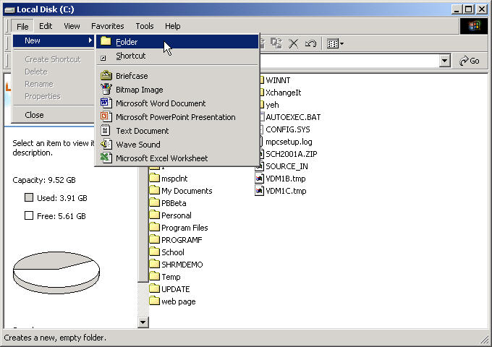
Add new folder screen

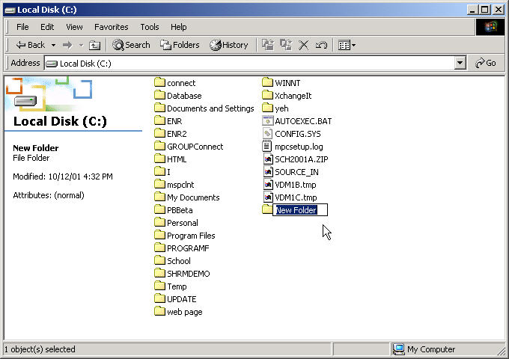
Enter folder names

Then go back to the XchangeIT interface and click Apply in the configuration details screen. The source in and out folders should then be saved.

Left click on the Timer tab across the top of the configuration details screen. This area is where the times at which XchangeIT is to automatically dial are set.

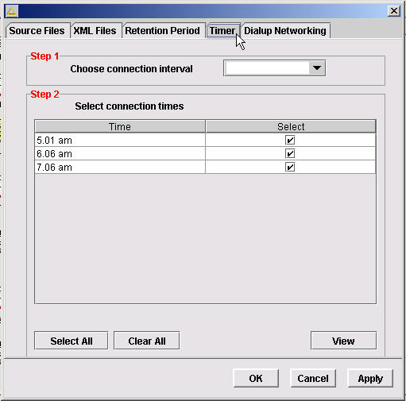
Timer Tab Screen

In the top part of this screen, there is a rectangular box labeled as Step 1 - Choose connection interval. Click the arrow at the right hand end of the rectangular drop box and you will be displayed the standard time intervals at which XchangeIT can be configured to dial out. Left click on 15 mins and in the section labeled Step 2 – Select connection times a listing will appear allowing you to determine the specific times at which XchangeIT is going to dial. Left click the square box under the Select column that relates to the time you would like XchnageIT to dial out to check for invoices and send sales files back. The times should be selected so that XchnageIT’s dial out is not going to effect anyone’s requirements for the computer. For example, if this computer is used to do magazine returns every afternoon at 4:00pm, make sure that you don’t select this as a time when XchnageIT needs to take control and dial out. Most users will find it suitable to schedule XchangeIT so that it dials twice or three times a day, at times when the shop is closed. NB: if you plan to schedule it this way and the dial up machine is not the server, you will need to ensure that both the dial up machine and the server are left on whenever you plan for XchangeIT to dial. Once you have selected all your dial up times, click the Apply button at the bottom right hand corner of the Timer tab screen.

Click the Dialup Networking tab along the top of the configuration details screen. The screen that appears is where the internet connection that XchangeIT is to use is set. To make sure you enter the details properly, firstly we’ll check what they are from your internet options. From the windows desktop, click the Start button at the bottom left hand corner of the screen, then click Settings then Control Panel.
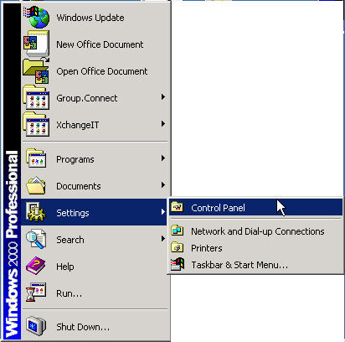

From the window that appears, double click the Internet options icon, which will open the window displaying your internet settings. Click the connections tab that appears at the top of the Internet options screen and your connection details will be displayed. Pay careful attention to the spelling of the service that is set up here, as when you come to entering it into XchangeIT, they must match exactly - this includes any capital letters, spaces etc. On this same screen, click the Settings button and the username for your connection will be displayed. The same rules as with the service name earlier apply here with regards to the exact spelling of the names. Your password will be encrypted in this screen, so you won’t be able to tell what it is from here, you may need to consult the documentation you received when you set up the service originally to find this out. Again, when you enter it into XchangeIT, it will need to be an exact match.

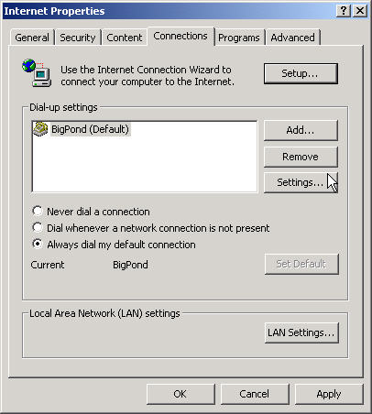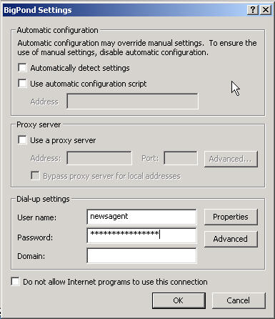

Close these windows by clicking the x that appears in the top right hand corner of the window and return to the XchangeIT interface, where the Dialup Networking tab should be displayed. Enter the service details as were displayed in the earlier steps into these fields and click the Apply button. Click the Ok button on this screen and the configuration details screen will close.

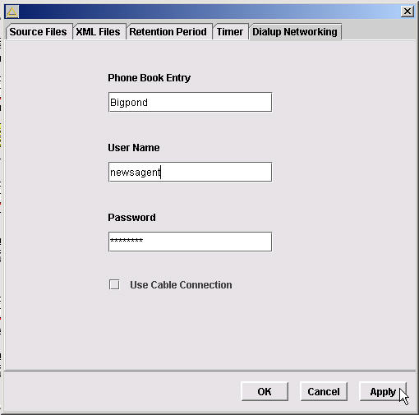
Dialup Networking screen

Stage 4: Applying for partnerships with the magazine suppliers

Now the configuration side of XchangeIT has been finalised, you are able to apply for partnerships with each of the magazine suppliers. To do this, from the Interface screen, in the left hand pane, click on the Partners icon, then click the Find button on the right hand side of the screen which appears. All three suppliers will then be listed.

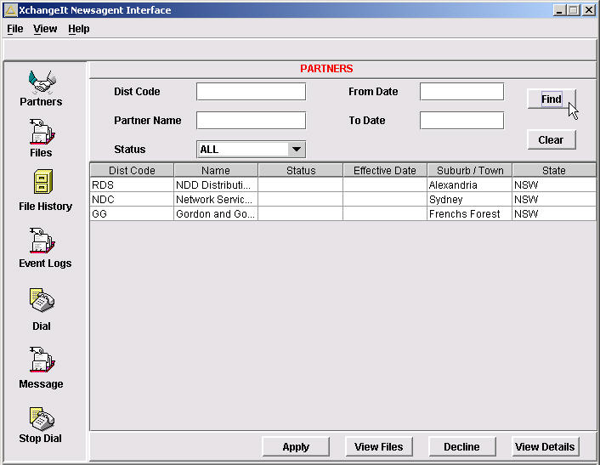
Partner screen

For each of the suppliers, left click their line so it is highlighted in blue, then click the Apply button. A screen will appear displaying all of the supplier’s details. You will need to enter your account number with each supplier in the field supplied and then click Ok.

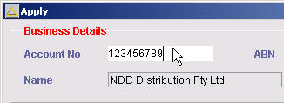
Account number entry screen

You will notice that the status for each supplier will have been changed to Submitted. There are three stages of status when it comes to your partnerships with the suppliers, these being Submitted, Pending and Active. The Active status is what is required before any invoices or sales files can be transmitted between the supplier and yourself.

In the left hand pane of the XchangeIT interface screen, there is an icon labeled Dial. Left click it and then Ok to perform a manual dial. The status of your application with each supplier will change automatically from Submitted to Pending to Active with each subsequent dial out that XchangeIT makes (as long as they are made at least 30 minutes apart from each other). The systems at the supplier’s end synchronize about every half an hour, so if you perform a manual dial and the status does not change, give it a break for about an hour and try and dial again to see if the status changes.

If there is a problem with your application for a partnership, you may see the status for the supplier flagged as Declined. In this case, contact the supplier to try and find out their reason for declining your application.

Stage 5: Configuring the Pos Solutions Software

You must firstly make sure that you have got the most recent version of the Pos software installed on your system and you have entered your XchangeIT registration number in the Company details screen of the Utilities menu (Main menu, #4 Utilities, #8 Company details, R for Registration). If you have not got this registration number, you can not configure the Pos system to use XchangeIT. To request a registration number, please contact the support department by calling (03) 9532 2733, email us at support@possolutions.com.au or from the Company details screen press P to print a request form and fax it to us in the office on (03) 9532 2778.

Once you have ensured your registration number has been entered, from the main menu, select #3 Updating system section, #20 Online section, #6 Service details. Press A to add a new service and ensure that all fields match as listed below. Press PgDn and Y for details correct.

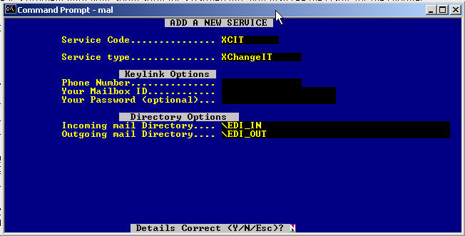

From the Online Section menu, select #7 Supplier details. For each supplier, type in the code that you use in your system – most are GG, RDS and NET – but other variations may exist. Once you have called them up on the screen, ensure that that the fields match as listed below (excepting that account numbers are entered specifically for each supplier). Also, the NAPost partner account field must be entered as follows:

Gordon & Gotch = GG
Retail Distribution Service = RDS
Network = NDC

Remember to press PgDn and Y for details correct for each supplier.

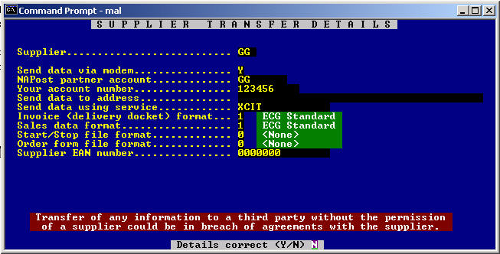

From the Online menu, press the letter O and the options section will be displayed. Select #24 EDI invoicing and ensure that the options match those listed below. Remember to press PgDn and Y for details correct.

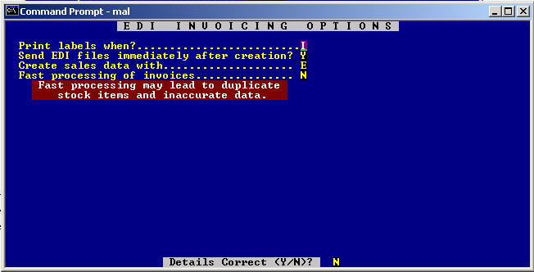

This concludes the setup & configuration stages of XchangeIT and the Pos Solutions software packages.

